**Assignment 2**

1. Write a SQL statement to create a table named jobs including columns job_id, job_title, min_salary and max_salary, and make sure that, the default value for job_title is blank and min_salary is 8000 and max_salary is NULL will be entered automatically at the time of insertion if no value assigned for the specified columns.

Answer ->

Create table jobs ( job_id varchar, job_title text default 'blank', min_salary numeric default 8000, max_salary numeric default null);

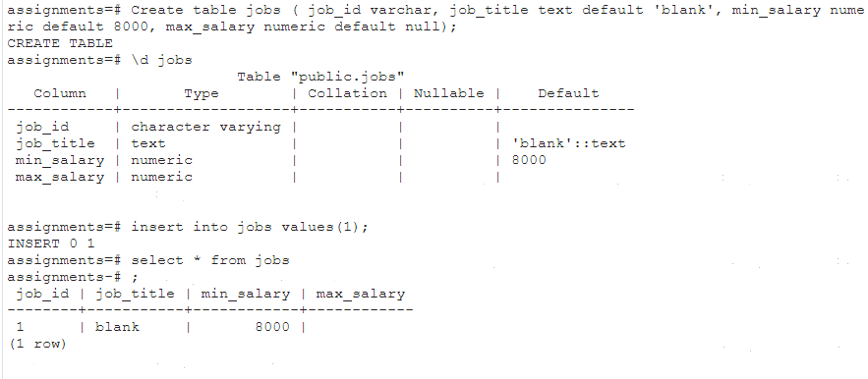

1. Write a SQL statement to create and insert a record into the table countries to ensure that, at country_id and the region_id combination will be entered once in the table.

Answer ->

Create table countries (country_id varchar, country_name text, region_id numeric, primary key(country_id,region_id));

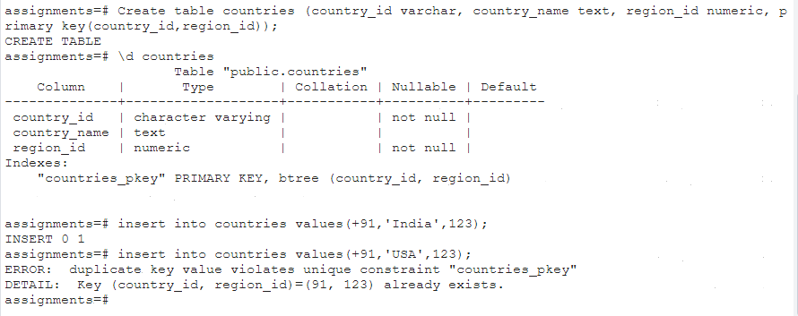

1. Write a SQL statement to create and insert records into the table countries to ensure that the country_id column will not contain any duplicate data and this will be automatically incremented and the column country_name will be filled up by 'N/A' if no value assigned to that column.

Answer ->

create table countries1(country_id serial,country_name varchar(20) default 'N/A',region_id numeric, primary key(country_id));

